FULFILLMENT OPERATIONS / FIRST SHIFT

Fulfillment team packing guide
Use this guide on your first fulfillment shift. Match every piece to its order, save a clear photo before wrapping, and complete the final check before sealing the box.
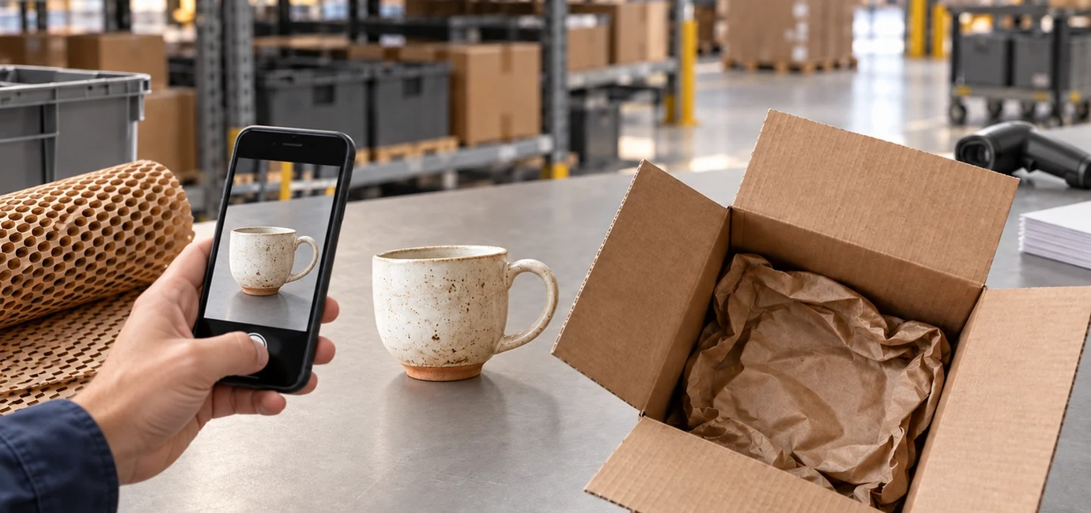

1 Check the order and the piece
Match the item, quantity and finish to the order. Check the rim, handle and surface for visible damage. If anything differs or looks damaged, set the piece aside and ask before packing.

2 Photograph the unwrapped piece
Photograph each piece before sealing. Take the photo before wrapping so the whole piece is visible. Save it with the order, then check that the image is clear and the correct piece is shown.
Keep the piece and its order together as you move to wrapping.

FULFILLMENT OPERATIONS / FINISHING THE ORDER

Protect the piece then seal
Keep the box open until the piece, order and saved photo have been checked together.
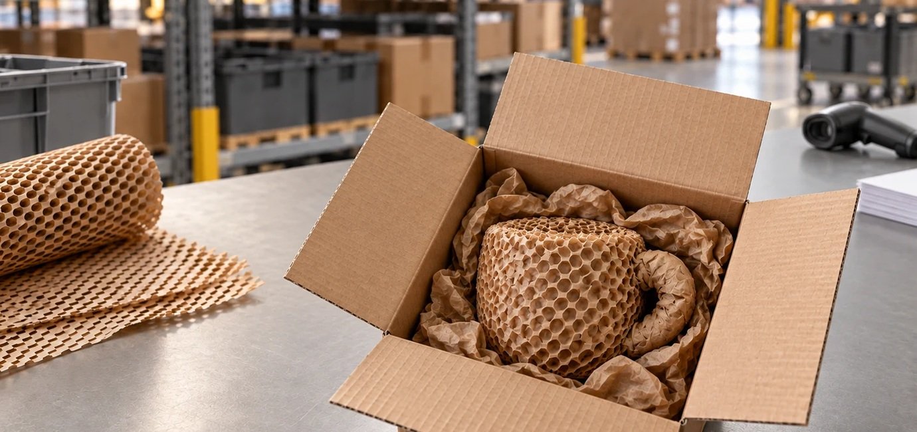

3 Wrap and protect
Wrap each piece separately. Protect rims and handles, and keep hard surfaces from touching. Use enough wrapping to hold the protection in place.

4 Cushion the open box
Cushion the bottom of the box. Set the wrapped piece inside, then fill the gaps around it so it stays supported. Leave the box open for the final check.

5 Check once more then seal
Confirm the piece and quantity against the order. Check that the photo is saved with the order and shows the correct, unwrapped piece. Then close and seal the box.
If the photo is missing or unclear, open the wrapping and take it before sealing.

